Recovery Delayed is Recovery Denied --
Austerity and Democracy in the EU
John Weeks

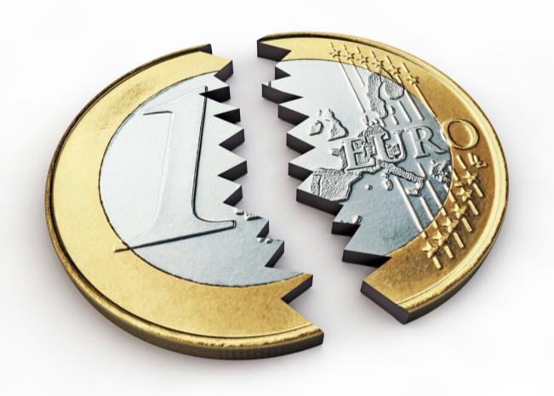
Thanks to Flickr.

Specter of Democracy in Greece

On 29 December 2014 the Greek parliament refused to endorse the presidential candidate of the country's ruling coalition. Needing 180 votes, Mr. Stavros Dimas managed only 168. As a result, the Prime Minister, Antonis Samaras, must call and has called a general election for 25 January.

This election in one of the smaller countries of European Union has set the European Commission (EC), the German government and the other austerity advocates alight with anxiety. Quite flagrant have been the attempts by the German Chancellor and her entourage to extort Greeks to vote for austerity.

Her economics minister, the hyper-austerian Wolfgang Schaeuble told the Greeks that austerity must continue whoever wins the election. Stated simply, Herr Schaeuble's message is, don't bother to hold the election, since popular demands to end austerity prompt it.

This heavy-handed election meddling provoked the leader of the right wing, Bavaria- based Christian Social Union (Merkel's partners in German mis-government, along with the woe-begotten Social Democrats) to warn the Chancellor, "we should not behave as a schoolmaster in the Greek election campaign".

This warning comes a bit late, for the EU "schoolmaster" is exactly the role played by the German government since mid-2010. Almost two years ago I attended an on-the- record speech in the German embassy in London by Peer Steinbrück, then the Social Democrat's choice for chancellor in the upcoming national election. In answer to a question from me he referred to Ireland as the "star pupil" of euro austerity programs, which wins marks for candour if not for sensitivity to national pride.

The reason that the German government, the Deutsche Bank and financial interests everywhere require tranquilizers when contemplating a Greek election is the clear and present danger that democracy might prove contagious in Europe. If Greek citizens vote in a government that repudiates austerity and wants to re-negotiated the public debt, who might be next - Estonia (election 1 March this year), Finland (19 April), and/or Spain (20 December)?

Stagnation in Euroland

Though economic growth is a clumsy measure of changes in citizen's welfare, suggests why those who gain form austerity should fear democratic accountability. You never know when people might decide they have had enough of the austerity scam (see my new book) and stop listening to "responsible" voices and turn to dreaded "populism" (aka, the majority will).

The chart below shows the decidedly grim tail. After almost seven years, US national output had crawled up to 9% more than the pre-crash level, hardly impressive but still an increase. For the non-euro Britain the increase has been more meager, 3%. The countries of the euro zone, even when Germany is included, are in aggregate 2 percentage points below where they were at the beginning of 2008. All pain, no gain.

Quarterly Gross National Product, percentage difference from 2008. USA, UK and the Euro zone (2008 1st quarter = 0)

10
USA +9
UK +3
Euro Zone -2
8

6
4
2

0
-2
-4

-6
-8
2014.3
2014.2
2014.1
2013.4
2013.3
2013.2
2013.1
2012.4
2012.3
2012.2
2012.1
2011.4
2011.3
2011.2
2011.1
2010.4
2010.3
2010.2
2010.1
2009.4
2009.3
2009.2
2009.1
2008.4
2008.3
2008.2
2008.1

Source: www.oecd.org/statistics.

The statistics at the country level tell a considerably grimmer EU story. Of the four largest euro countries, two are above where they were at the beginning of 2008, Germany by a UK-matching 3%, and France scraping in at plus 1%. These are the "success" stories, if up one percent can be so judged.

Italy and Spain remain far below where they were in 2008, Italy down 9 percentage points and Spain at minus 6. The extreme optimist might assess Spain as "over the worst", though still below where it was three years ago. Not even Pollyanna would

find cheer in the Italian performance, minus nine compared to 2008 and still on a downward slope.

Lucky for the austerity advocates that Italy has no election this year, where the government has complained about the EC's "shaky accounting" practices in calculating the country's deficit (you read that correctly, by EC rules Brussels makes the official calculation of the Italian deficit - and for every other euro country).

Quarterly Gross National Product, percentage difference from 2008. France, Germany, Italy and Spain (2008 1st quarter = 0)

4

France +1
Germany +3
Italy -9
Spain -6

2

0

-2

-4

-6

-8

-10
2014.3
2014.2
2014.1
2013.4
2013.3
2013.2
2013.1
2012.4
2012.3
2012.2
2012.1
2011.4
2011.3
2011.2
2011.1
2010.4
2010.3
2010.2
2010.1
2009.4
2009.3
2009.2
2009.1
2008.4
2008.3
2008.2
2008.1

Source: www.oecd.org/statistics.

Moving south and west the story becomes worse, with austerity-ravaged Greece down a catastrophic 26 percentage points. By comparison, the minus three for Ireland and minus 7 for Portugal seem benign. For all three the GDP decline seriously understates the contraction of household income and purchasing power. The three countries saw trade deficits in 2008 change to surpluses in 2014.

A trade surplus is great for creditors, because it finances the capital outflow to service debts to banks (in Germany, for example, rather a coincidence, isn't it?). For the residents in a country surpluses mean the opposite -- goods and services not consumed at home. Ireland is the "star pupil", household income a full 15% below 2008, while GDP is only three percent down.

Quarterly Gross National Product, percentage difference from 2008. Greece, Ireland and Portugal (2008 1st quarter = 0)

0
Greece -26
Ireland -3
Portugal -7
2014.3
2014.2
2014.1
2013.4
2013.3
2013.2
2013.1
2012.4
2012.3
2012.2
2012.1
2011.4
2011.3
2011.2
2011.1
2010.4
2010.3
2010.2
2010.1
2009.4
2009.3
2009.2
2009.1
2008.4
2008.3
2008.2
2008.1

-5

-10

-15

-20

-25

-30

Source: www.oecd.org/statistics.

Then we have the countries whose governments have been more Teutonic than the Germans in their support of euro austerity, Austria, Belgium, Finland and Netherlands. As for the four largest euro countries the score is two up, two down, with the latter outweighing the former when we add up. Perhaps most shocking is Finland, GDP down seven percentage points, but total government support for austerity, a government that includes the Left Alliance.

Indeed, last year when I visited Helsinki two members of the Left Alliance had just been expelled for criticizing the government's support for the draconian Greek austerity program. If Greek voters reject austerity, perhaps nominally progressive parties in Finland and elsewhere might re-consider their austerity enthusiasm, which is the fear of European finance capital.

Quarterly Gross National Product, percentage difference from 2008. Greece, Ireland and Portugal (2008 1st quarter = 0)
2014.3
2014.2
2014.1
2013.4
2013.3
2013.2
2013.1
2012.4
2012.3
2012.2
2012.1
2011.4
2011.3
2011.2
2011.1
2010.4
2010.3
2010.2
2010.1
2009.4
2009.3
2009.2
2009.1
2008.4
2008.3
2008.2
2008.1

3

Austria +2 Belgium +2 Finland -7
Netherlands -2
2
1
0
-1
-2
-3
-4
-5
-6
-7
-8
-9
-10

Recovery Denied

The charts trace the performance of eleven euro zone countries, seven of which have national incomes lower than at the beginning of 2008 and four with increases. The "recovery" of one, France, is a pathetic one percentage point, Austria and Belgium two percentage points, and Germany an unimpressive three. Meanwhile, the euro is in free-fall against the dollar, down to $1.18 compared to close to 1.40 about a year ago, what the New York Times considers the judgment of "currency markets" on "European leaders".

At some point all eleven will regain the early 2008 level of GDP. But, the loss of skills through extended unemployment and under-funded education will weigh on European growth for a generation or more. The ill-will towards immigrants fanned by austerity generated despair will taint European democracy for even longer. Resentment against the German government for relentlessly enforcing an inhumane economic program has and will rekindle old resentments.

In her New Year's speech Angell Merkel attacked anti-immigrant groups in Germany and the intolerance they foster. The penny seems not to have dropped for the Chancellor that the austerity policies she promotes are a major cause of the growth of anti-immigrant politics throughout Europe (if you don't believe me, hear it from CNN).

Recovery has not arrived in the euro zone, and when it does arrive it will be so long delayed that it will be recovery denied, with a legacy of economic and political darkness.

